Requirement Analysis

Technology Stack (Architecture & Stack)

Date | 11 September 2026
Student Name | Yuvasri Malla
Project Name | Licensed Software Installation Request Management
Maximum Marks | 4 Marks
Technical Architecture
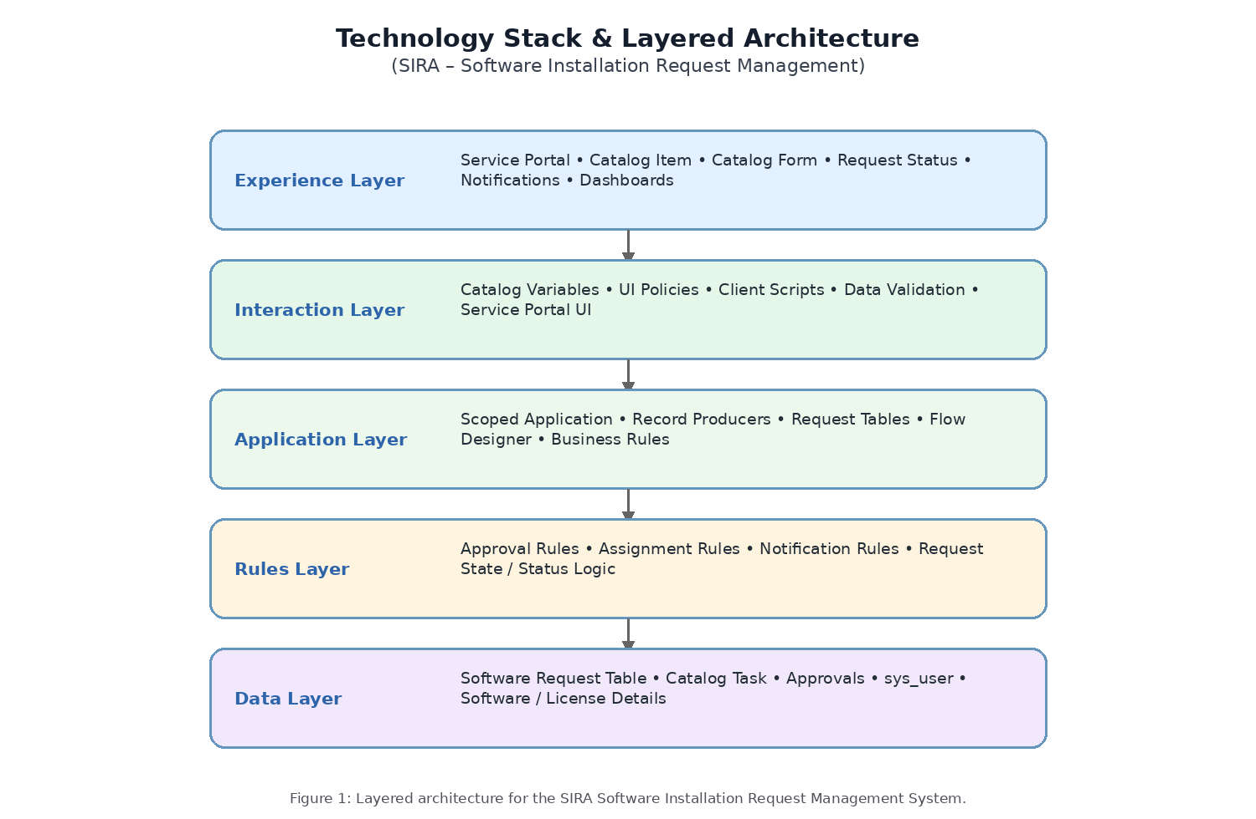
S.No. | Component | Description | Technology
1 | User Interface | Employee-facing interface for submitting and tracking licensed software installation requests. | Service Portal / Service Catalog
2 | Application | Handles software request creation, catalog processing, approvals, and request lifecycle. | ServiceNow Scoped Application / Catalog Item
3 | Rules | Controls mandatory fields, dynamic form behavior, validation, approvals, and notifications. | UI Policies / Client Scripts / Business Rules
4 | Data | Stores software request details, user information, approvals, and fulfillment task records. | Request Table / Catalog Task / sys_user
5 | Automation | Automates approvals, assignment, task creation, status updates, and notifications. | Flow Designer / Approvals / Notifications
6 | Fulfillment | Assigns installation work and tracks fulfillment until the software request is completed. | Catalog Tasks / Assignment Groups

Architecture Summary
The SIRA solution follows a layered servicenow architecture. The Experience Layer provides the catalog and request-tracking experience; the Interaction Layer manages variables and dynamic form behavior; the Application and Rules Layers manage request processing, validation, approvals and notifications; and the Data Layer stores request, user, approval and fulfillment information.

